COMPUTER NETWORKS

Assignment 1 Report

G SAI SHASANK

22CS10025

**Part 1: Networking Tools**

**1 Task 1: Find the IP Address, Subnet Mask, an Network ID**

Using the ifconfig command, we identified the following:

* IP Address of the Machine: 10.5.16.169
* Subnet Mask: 255.255.255.0
* Network ID: 10.5.16.255

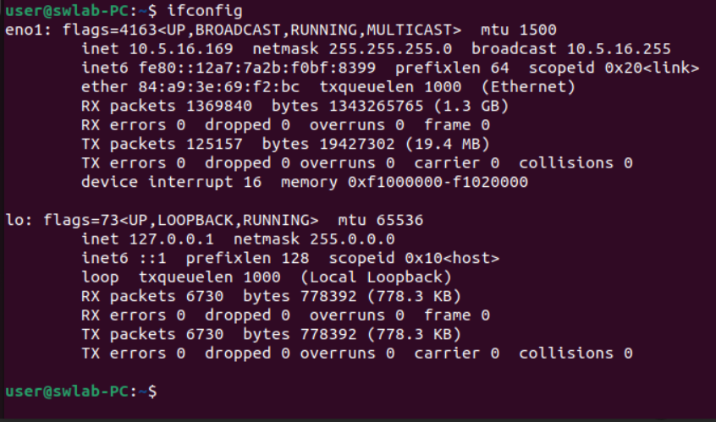

Output of ifconfig showing IP address, subnet mask, and network ID.

**2 Task 2: Resolve Domain Names using nslookup**

Using nslookup, the IP addresses for www.google.com and www.facebook.com were obtained:

* IP Address of www.google.com: 142.250.182.196
* IP Address of www.facebook.com: 31.13.79.35

When the DNS server address was changed to 172.16.1.164, 172.16.1.180, 172.16.1.165, and 172.16.1.166, the IP address of www.google.com was observed to change. This behavior is due to the load-balancing mechanisms used by DNS servers. These mechanisms ensure that traffic is distributed efficiently across multiple servers, improving performance, reliability, and redundancy.

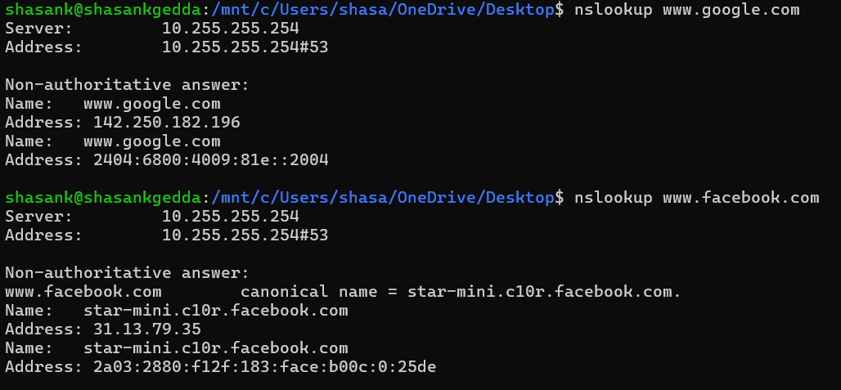

IP address associated with [www.google.com](http://www.google.com) and [www.facebook.com](http://www.facebook.com)

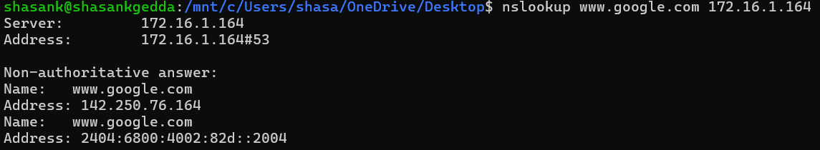

IP address of [www.google.com](http://www.google.com) with DNS address 172.16.1.164

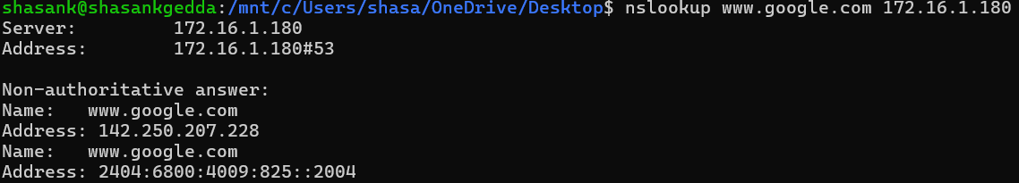

IP address of [www.google.com](http://www.google.com) with DNS address 172.16.1.180

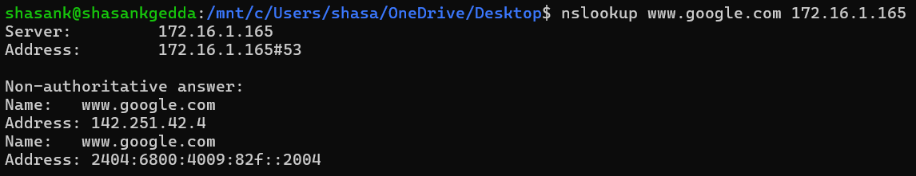

IP address of [www.google.com](http://www.google.com) with DNS address 172.16.1.165

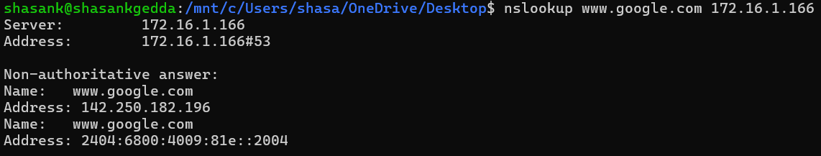

IP address of [www.google.com](http://www.google.com) with DNS address 172.16.1.166

|  |  |
| --- | --- |
| DNS | IP Adress |
| 172.16.1.164 | 142.250.76.164 |
| 172.16.1.180 | 142.250.207.228 |
| 172.16.1.165 | 142.251.42.4 |
| 172.16.1.166 | 142.250.182.196 |

**3 Task 3: Ping Command with Different Packet Sizes**

Using the ping command, packets were sent to a friend’s machine with varying sizes:

* Friend’s IP Address: 10.5.16.152
* Packet Sizes: 64, 128, 512 bytes.
* Timeout: 100ms.

Results Table:

The results of the ping command with varying packet sizes are summarized below:

|  |  |  |
| --- | --- | --- |
| Packet Size (bytes) | Packet Loss (%) | Round-Trip Time (min/avg/max/stddev) |
| 64 | 0 | 2.375 / 8.033 / 28.504/ 5.954 |
| 128 | 0 | 3.398 / 8.363 / 20.583/ 4.853 |
| 512 | 0 | 2.270 / 7.643/ 18.256 / 3.963 |

Screenshots:

The following images show the ping command outputs for each packet size:

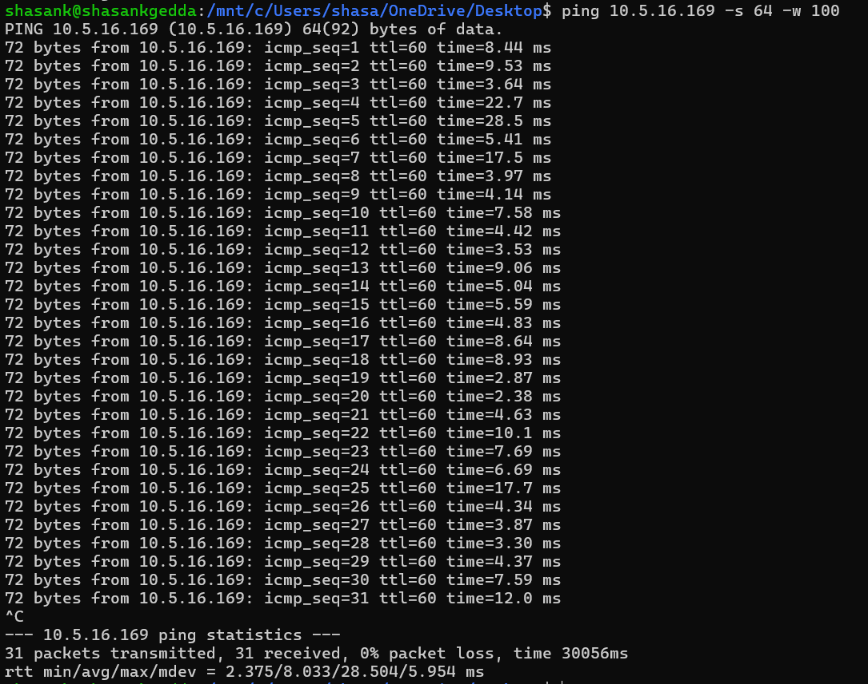

Ping output for 64-byte packets.

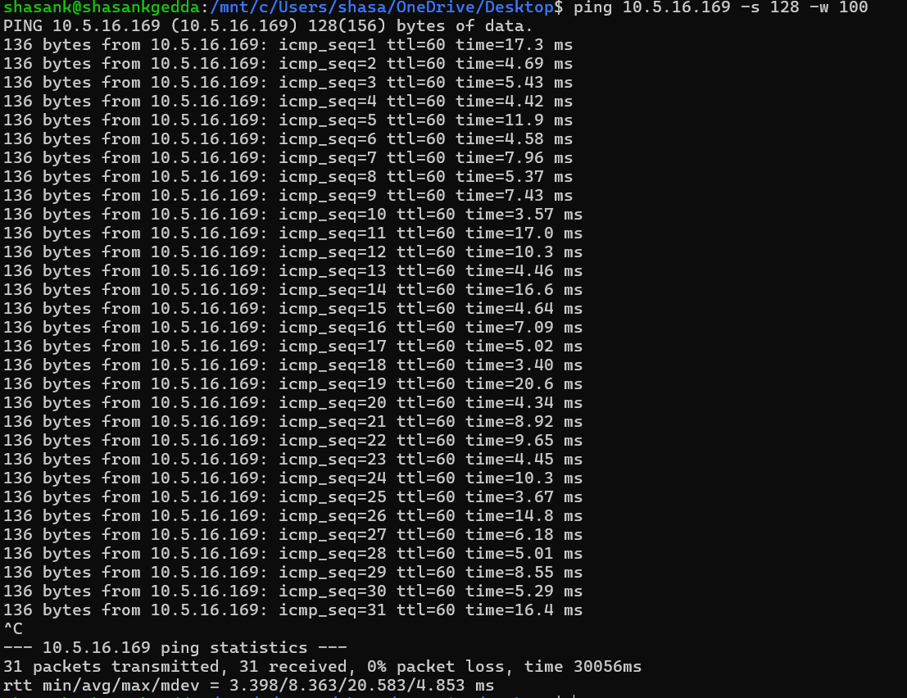

Ping output for 128-byte packets.

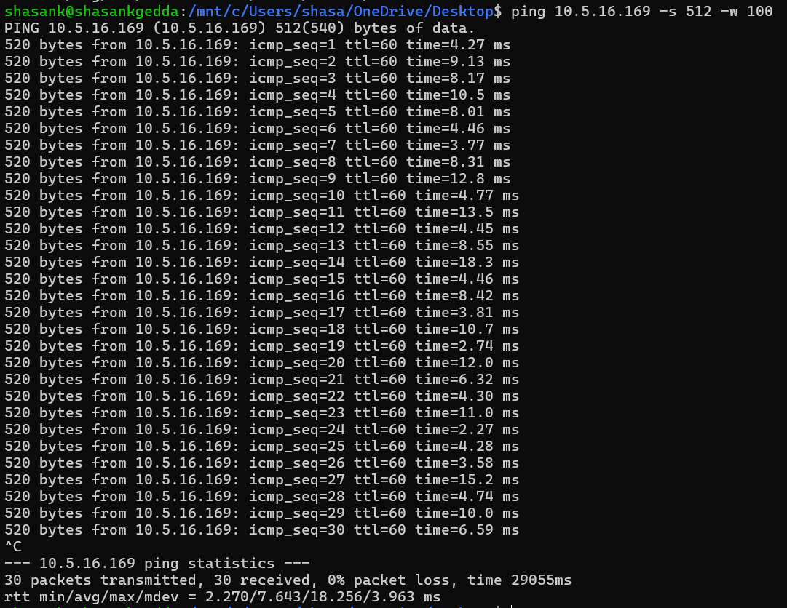

Ping output for 512-byte packets.

**4 Task 4: Traceroute Command**

Using the traceroute command, the path to www.google.com was analyzed. The number of hosts involved in the path from source to destination was counted.

Summary of Results:

• Number of Hosts: 13

• Observed “* * *” in intermediate hops: These indicate timeouts or unreachable hosts, often caused by network policies or firewalls or TTL expiration without response

Screenshot of the output:

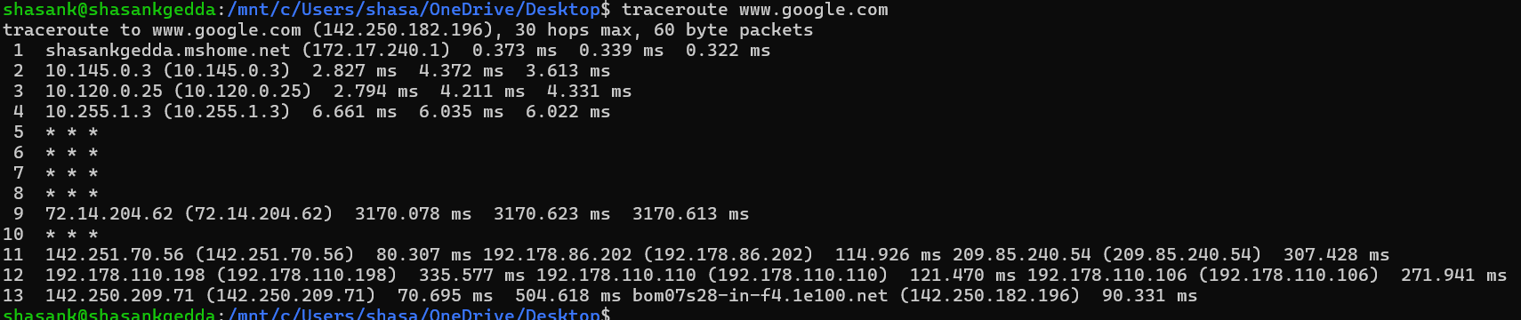

Output of traceroute for [www.google.com](http://www.google.com).

**Part 2: Packet Analysis**

1. DNS Packets Analysis

* DNS Query/Response Protocol: UDP
* Source IP Address of DNS Query: 10.5.16.169
* Destination IP Address of DNS Query: 172.16.3.10
* Number of DNS Queries Sent: 12
* DNS Server Replying with IP Address: 172.16.3.10
* Number of DNS Servers Involved: 1

Resource Records:

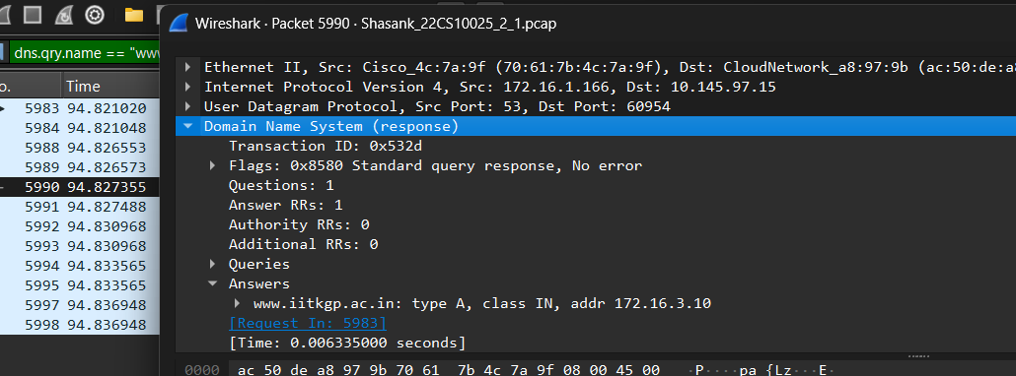 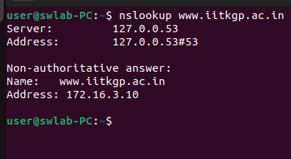

DNS Response nslookup response

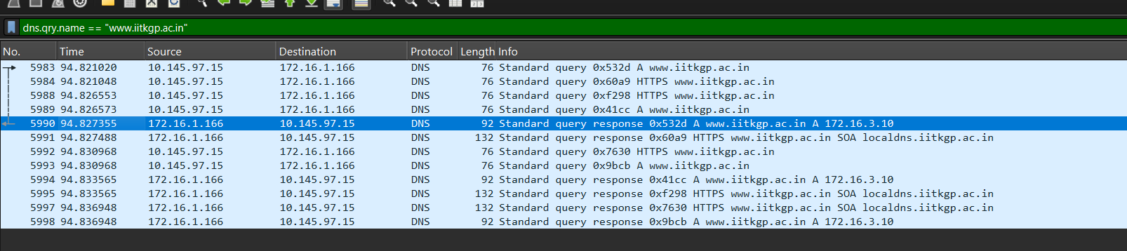

DNS query and response captured in wireshark

**2. Web Traffic (HTTP) Analysis**

* Number of HTTP Packets Exchanged: 10
* HTTP Request: GET / ̃grovesd/ HTTP/1.1
* HTTP Response: HTTP/1.1 200 OK (text.html)

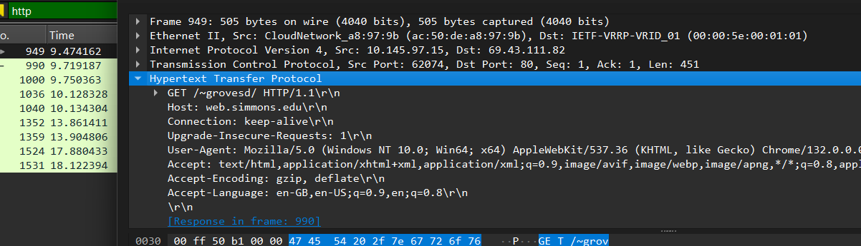

1. HTTP Request

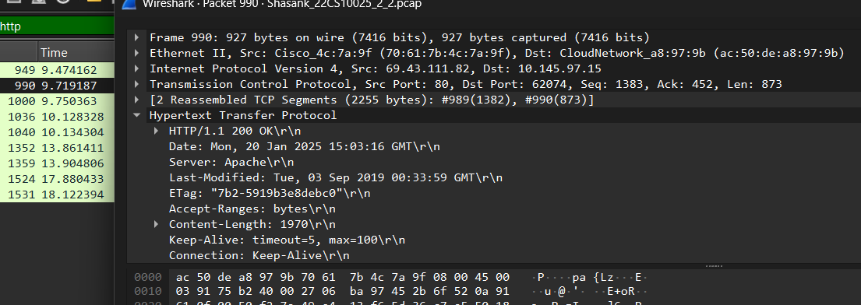

1. HTTP Response

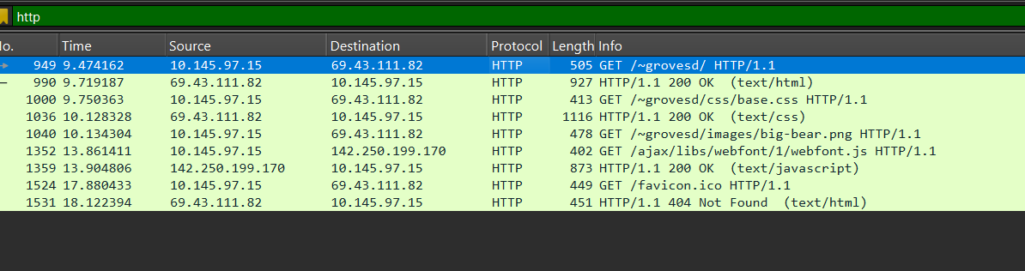

1. HTTP Request 3.

Figure 14: HTTP Request and Response for http://web.simmons.edu/ grovesd/.

**3. ICMP Traffic (Ping/Traceroute)**

* Ping to Friend’s IP: 10.5.16.169
* Traceroute to Friend’s IP: 10.5.16.169
* Ping to Unreachable Host: 192.168.1.100

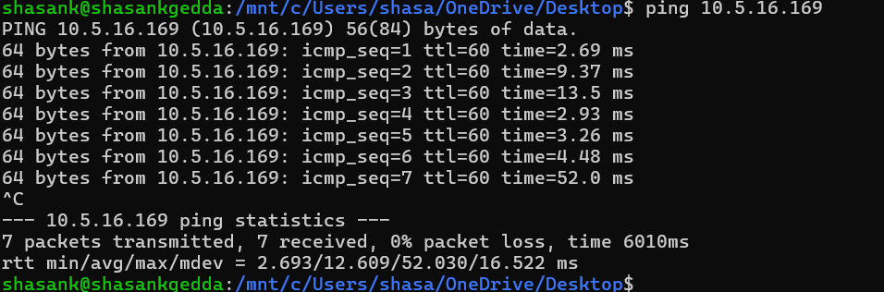

(a) ping and traceroute to 10.5.16.169

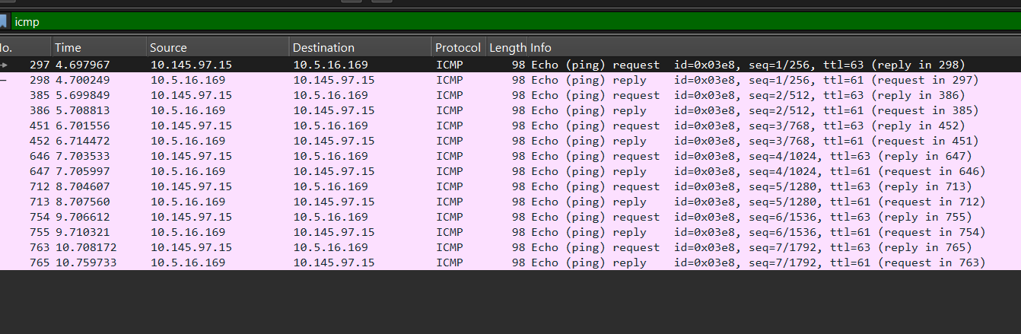

(b) ”ping” and ”traceroute” captured in Wireshark.

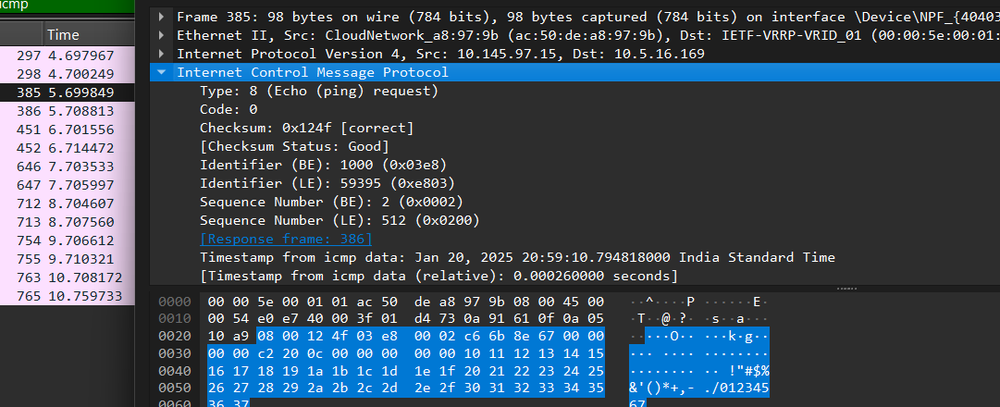

( c ) Analysis of ping request

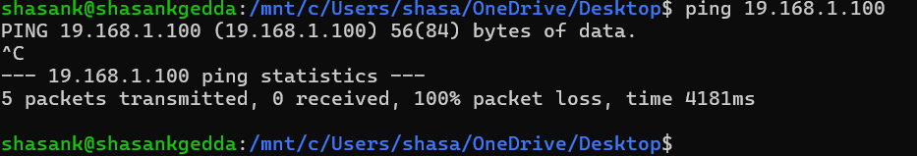

1. ping to unreachable host(19.168.1.100)

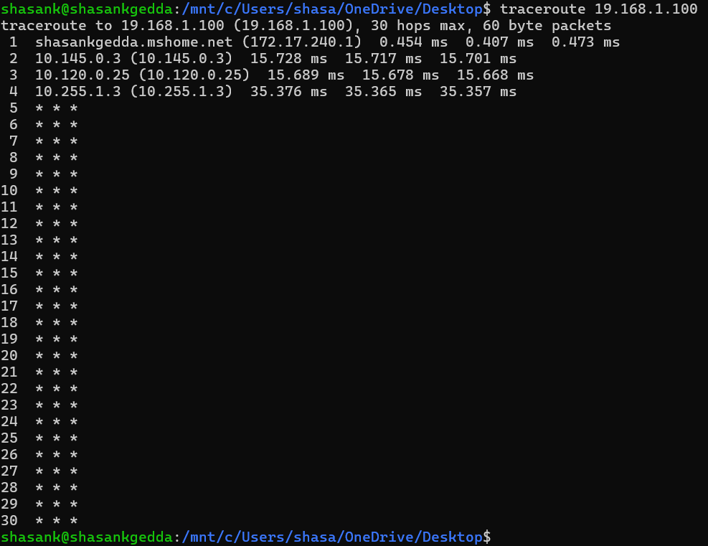

( e ) Trace to unreachable host(19.168.1.100)

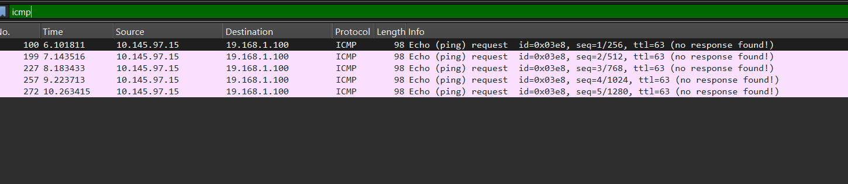

(f) ”ping” and ”traceroute” captured in Wireshark

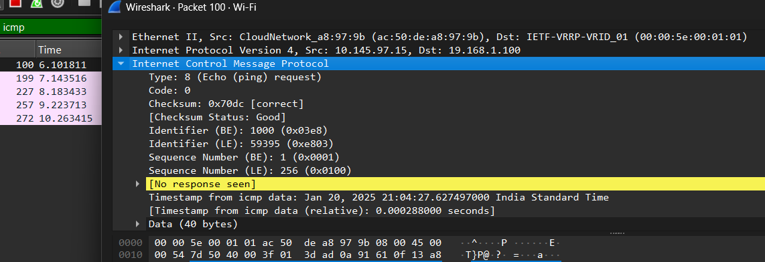

( g ) Analysis of ping request ( unreachable host )